BRILLIANT MINDS ACHIEVING DISTINCTION CURRICULUM OVERVIEW – INFORMATION SHEET

Overview:

The four-week Brilliant Minds Achieving Distinction (BMAD) curriculum from Brothers Making a Difference includes activities, pre and post-tests, evaluative metrics, guest speakers, worksheets, reflection exercises, and daily check-ins. Attendance is a priority, with incentives given to participants who attend the full four-week program. Those who finish the program receive a certificate of completion and a copy of Jermaine’s book, “Why Jermaine?”

Mission:

The BMAD curriculum from Brothers Making a Difference provides participants with the tools, guidance, and follow-up to ensure the cultivation of energy, respect, passion, and consistency in personal and professional endeavors.

Vision:

The BMAD curriculum from Brothers Making a Difference will enable participants to make a continuous difference in their communities through the consistent application and reflection of energy, respect, passion, and consistency in personal and professional endeavors.

Outcome:

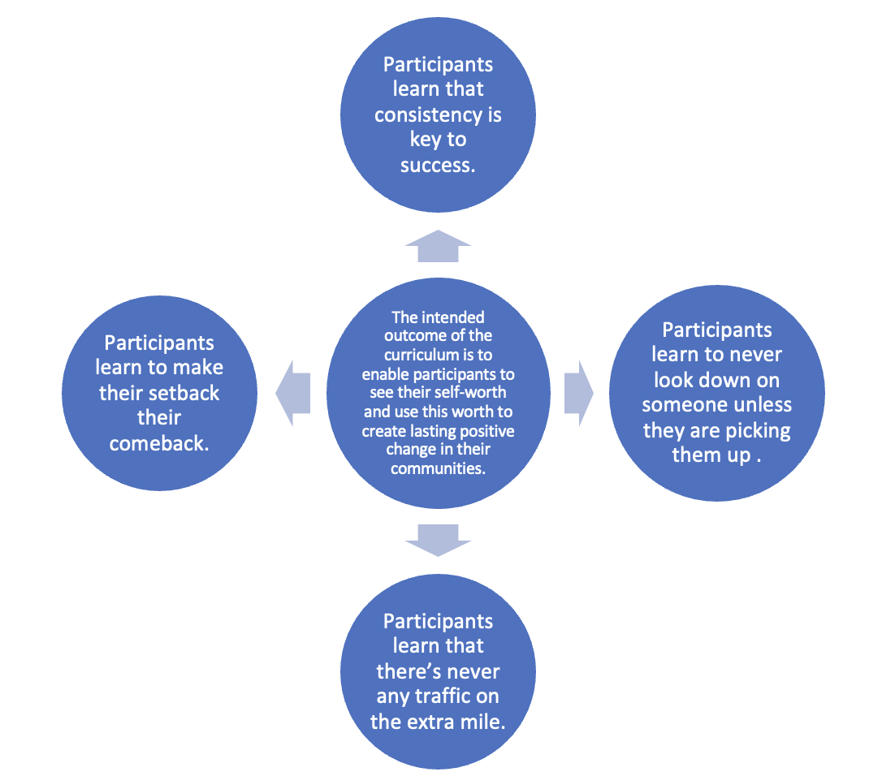

Measurable Outcomes:

- Attendance sheets and records
  - Week to week attendance by participant
  - Week to week attendance, general

- Deliverables completed by participants

- Post-session satisfaction survey (guardians and participants)

- Pre/Post-test Growth

Evaluation Model:

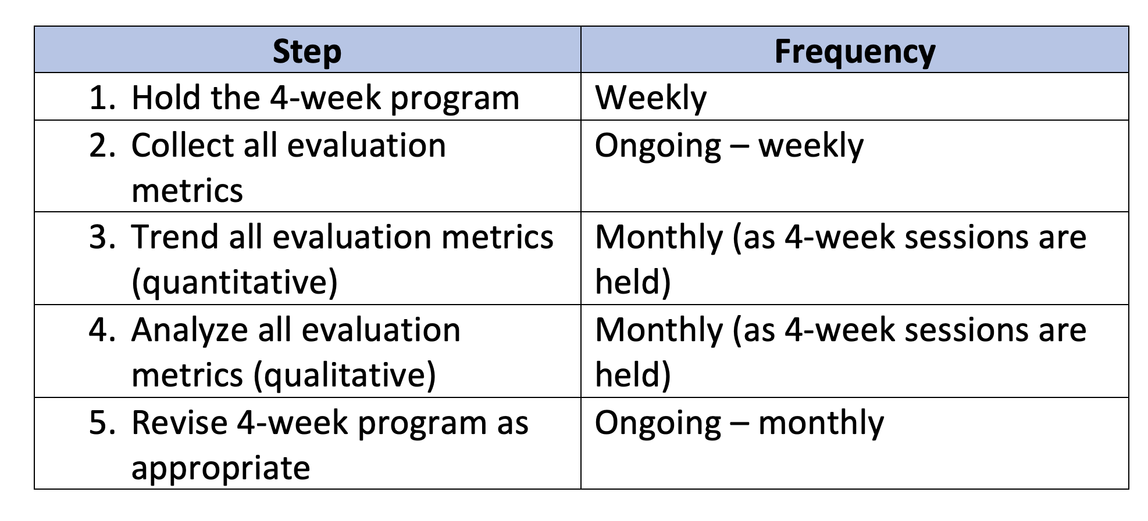

Logistics:

Each session lasts one hour and there are four sessions in the curriculum for a total of four hours of classroom time.

Instructor to student ratio is recommended to be 1:20 or less; anything more than 1:25 will make it difficult to individualize instruction and follow-up as the curriculum prescribes.

